MENG 4010 – INDUSTRIAL NETWORKING
Lab 08 Report – Introduction to Wireshark: Capturing and Analysing ICMP, ARP, DNS, TCP, UDP and DHCP Traffic

Item | Details
Student | Michael McCorkell (N01500049)
Course | MENG 4010 – Industrial Networking
Lab Date | September 16, 2026
Equipment | Windows laptop with a MediaTek Wi-Fi 6E MT7922 wireless adapter (MAC BC-F4-D4-E2-37-DD)
Software / tools | Wireshark 4.6.8 (64-bit) with Npcap 1.88; Windows Command Prompt / PowerShell (ipconfig, tracert, ping, arp, netstat); web browser

Instructor’s Confirmation
The course instructor’s signature below verifies completion of the lab demonstration.
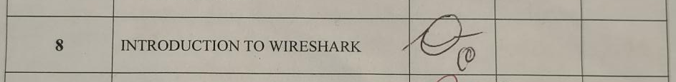

1. Assignment Summary

1.1 Objectives
The purpose of this lab was to install Wireshark, capture live network traffic, and connect what appears in the packet headers to the protocols studied in class. The specific objectives were to:
- Install Wireshark with Npcap, record the workstation’s network settings with ipconfig /all, and capture traffic on the active wireless interface.
- Identify and inspect at least five protocols (ICMP, ARP, DNS, TCP and UDP were found, plus DHCP and NBNS) by filtering the capture and expanding the Ethernet II, IPv4 and transport-layer headers.
- Observe how the IP Time-to-Live (TTL) field and ICMP Time Exceeded messages make traceroute work, and follow a TCP three-way handshake and an HTTP GET request.
- Generate traffic with ping, arp, ipconfig, netstat and tracert and match each command to the packets it produced in Wireshark.

1.2 Work Completed
The lab was completed in three parts using two saved captures (Wireshark_ICMP_Michaël.pcapng and Wireshark_TCPUDP_Michaël.pcapng) and live captures for Part C. Table 1 summarises each part and Table 2 lists the network each capture was taken on, because the addresses differ between figures. The supporting screenshots are in Section 2.
Table 1 – Summary of the three parts
Part | Task | Traffic observed | Key result
A | tracert www.netfirms.com with a capture running on the Wi-Fi interface | ICMP, ARP, DNS, TCP, UDP | Route starts 10.111.0.1 → 10.200.0.105 → pa-edge.humber.org → n-rtr-ext.humber.org → 66.97.22.128 → 66.97.16.3; gateway returned ICMP Time Exceeded (Type 11) in frame 96
B | Open http://www.textfiles.com/virus/datut010.txt and filter tcp / udp | TCP handshake, HTTP GET, DNS, NBNS, DHCP | SYN, SYN-ACK, ACK between 192.168.0.213:50622 and 208.86.224.90:80 (about 38.6 ms to the SYN-ACK), then the HTTP GET
C | ping 8.8.8.8, arp -a, ipconfig /all, netstat -an, tracert www.google.com | ICMP, ARP, TCP | 4 of 4 ping replies (average 18 ms, TTL 116); gateway MAC 38-4f-49-4d-b8-80 resolved by ARP; Google reached on hop 8

Table 2 – Capture sessions and addressing
Used for | Workstation IPv4 | Default gateway | Notes
Part A (Figures 3–10) | 10.111.14.18, mask 255.255.128.0 | 10.111.0.1 (MAC 38:4f:49:4d:b8:80) | Campus network (humber.org); DHCP server 10.114.0.41; capture saved 12:04 PM
Part B: TCP, DNS query, UDP header (Figures 11–14, 16, 18–19) | 192.168.0.213 | 192.168.0.1 (MAC 04:95:e6:94:f3:f0) | A private 192.168.0.0/24 network; capture saved 3:39 PM
Part B: NBNS, DHCP (Figures 15, 17) and Part C (Figures 20–28) | 10.111.16.166, mask 255.255.128.0 | 10.111.0.1 (MAC 38:4f:49:4d:b8:80) | Campus network; DHCP server 10.114.128.109

1.3 Conclusions
Every required protocol was captured and could be decoded layer by layer. The most useful result was seeing that each packet is a set of nested headers: Ethernet II carries the MAC addresses for the local link, IPv4 carries the end-to-end addresses and the TTL, and ICMP, TCP or UDP sits inside the IP packet. The same values that ipconfig reports (IP address, gateway, MAC address, DHCP and DNS servers) appear again in the headers, which confirms the tools and the capture agree with each other.
Three observations stood out. First, TTL is what makes traceroute possible: each router that discards an expired packet reveals itself in an ICMP Time Exceeded message. Second, TCP sets up a connection with SYN, SYN-ACK and ACK and tracks every byte with sequence and acknowledgement numbers, whereas UDP simply sends a datagram with an 8-byte header and no handshake. Third, the command-line tools are only a front end for these protocols: ping is ICMP echo, tracert is ICMP with a rising TTL, and arp -a only displays the cache that ARP requests fill in. The same skills apply on an industrial network, where Wireshark can decode protocols such as EtherNet/IP, Modbus/TCP and S7comm to diagnose latency or a misconfigured device.

2. Program Documentation
Screenshots are grouped by part. Key values are stated in the text and in the figure captions, and the Wireshark title bar of each expanded packet shows the capture file it came from.

2.1 Part A – IP and ICMP Analysis Using Traceroute
Installation and network information. Wireshark 4.6.8 (64-bit) was installed with the default options. Npcap 1.88 was installed when prompted (Figure 1) and USBPcap was left unchecked because USB traffic was not being captured (Figure 2). ipconfig /all (Figure 3) recorded the settings for this capture: IPv4 address 10.111.14.18, subnet mask 255.255.128.0, default gateway 10.111.0.1, MAC address BC-F4-D4-E2-37-DD, DHCP server 10.114.0.41 and DNS servers 10.114.0.252 and 10.114.255.252.
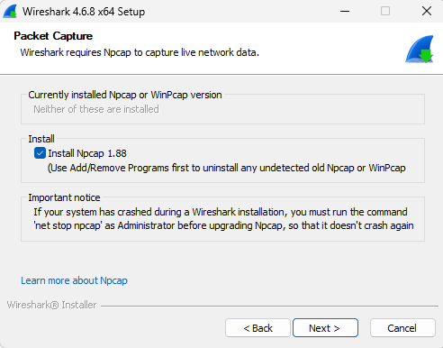  Figure 1 – Installer: Npcap 1.88 selected | 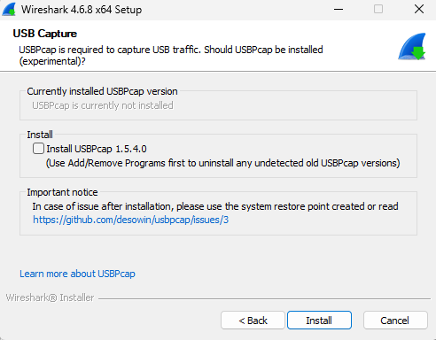  Figure 2 – Installer: USBPcap not selected

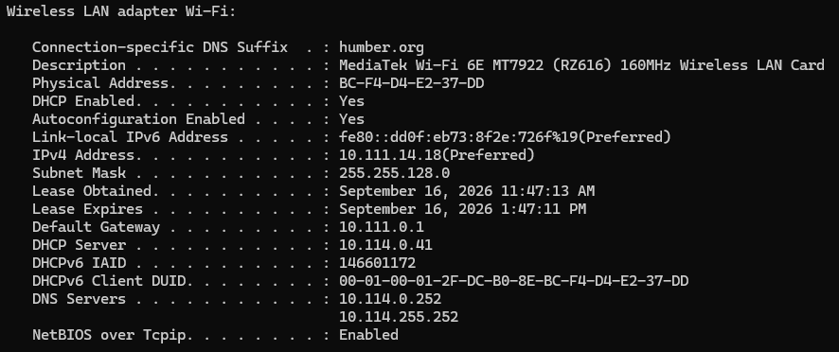
Figure 3 – ipconfig /all: IP 10.111.14.18, mask 255.255.128.0, gateway 10.111.0.1, MAC BC-F4-D4-E2-37-DD
Traceroute. With the capture running on the Wi-Fi interface, tracert www.netfirms.com was run (Figure 4). The name resolved to 104.18.38.156. The first six hops in the screenshot are 10.111.0.1 (the gateway), 10.200.0.105, pa-edge.humber.org (10.200.0.254), n-rtr-ext.humber.org (192.75.71.129), 66.97.22.128 and 66.97.16.3. After the first hop (28–51 ms, the wireless link) each hop answered in 4–16 ms. The capture was then stopped and saved as Wireshark_ICMP_Michaël.pcapng (Figure 5).
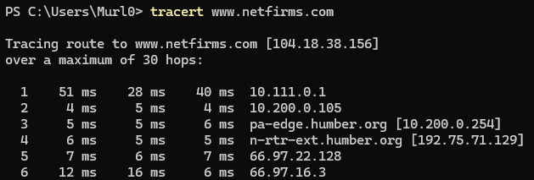
Figure 4 – tracert www.netfirms.com [104.18.38.156]: first six hops
Figure 5 – Capture saved as Wireshark_ICMP_Michaël.pcapng
How TTL and Time Exceeded work. Every IPv4 packet carries a Time-to-Live field, and each router decrements it by one. When a router receives a packet whose TTL would reach 0 it discards the packet and returns an ICMP Type 11 (Time Exceeded) message to the source, which reveals the router’s address. tracert uses this by sending Echo Requests with TTL 1, 2, 3 and so on, so each router along the path answers in turn; it sends three probes per hop, which is why three times appear on each line of Figure 4. The trace ends when the destination itself answers with an Echo Reply (Type 0).
Protocol inspection. Five protocols were found in the capture by applying a display filter (icmp, arp, dns, tcp, udp), selecting one packet and expanding the Ethernet II, IPv4 and transport-layer headers (Figures 6–10). DHCP, HTTP and LLDP were not selected for Part A.
ICMP (Figure 6, frame 96). Ethernet II source 38:4f:49:4d:b8:80 (the gateway) to destination bc:f4:d4:e2:37:dd (the workstation), type 0x0800. IPv4 source 10.111.0.1, destination 10.111.14.18. The ICMP message is Type 11 (Time-to-live exceeded), Code 0 (in transit), checksum 0xf4ff (correct). An ICMP error quotes the packet that caused it: the embedded IPv4 header shows 10.111.14.18 → 104.18.38.156 and the embedded ICMP is the Echo request (Type 8) with identifier 1 and sequence number 27. This is the gateway, the first hop, reporting that a probe expired.
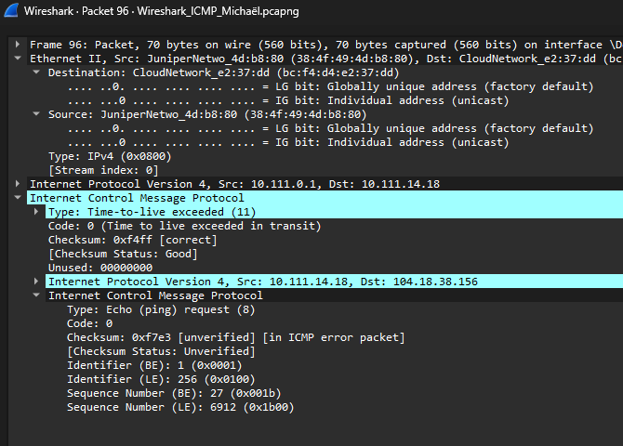
Figure 6 – ICMP frame 96: Time Exceeded (Type 11) from gateway 10.111.0.1, quoting the original Echo request
ARP (Figure 7, frame 242). A 42-byte broadcast: Ethernet destination ff:ff:ff:ff:ff:ff, type 0x0806. ARP hardware type Ethernet (1), protocol type IPv4 (0x0800), hardware size 6, protocol size 4, opcode request (1). Sender bc:f4:d4:e2:37:dd / 10.111.14.18; target MAC 00:00:00:00:00:00 (unknown, which is what the request asks for) and target IP 169.254.169.254. That target is a link-local address, not the gateway, so this request was most likely generated by background software rather than by tracert.
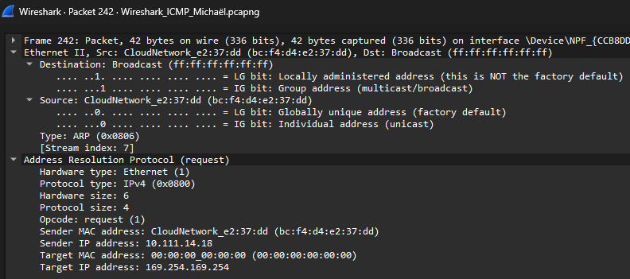
Figure 7 – ARP request, frame 242: sender 10.111.14.18, target 169.254.169.254, target MAC all zeros
DNS (Figure 8, frame 88). A response sent over UDP from 10.114.0.252 port 53 (the DNS server listed by ipconfig) to 10.111.14.18 port 65006. Transaction ID 0x6065, flags 0x8180 (standard query response, no error), 1 question and 2 answer records, response time 6.9 ms (request in frame 87). This is most likely the lookup that produced 104.18.38.156 for www.netfirms.com; the queried name is in the collapsed Queries section.
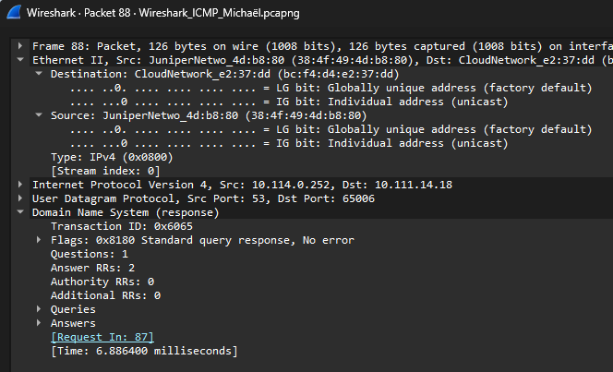
Figure 8 – DNS response, frame 88: 10.114.0.252:53 → 10.111.14.18:65006, 2 answers, 6.886 ms
TCP (Figure 9, frame 68). 10.111.14.18 port 53909 to 162.159.134.234 port 443 (HTTPS). Sequence number 1, acknowledgement number 338, length 0, flags 0x010 (ACK only), window 507, header length 20 bytes. This is a pure acknowledgement with no data: relative acknowledgement 338 means the client has received 337 bytes from the server. The Ethernet destination is the gateway’s MAC address even though the IP destination is a remote server.
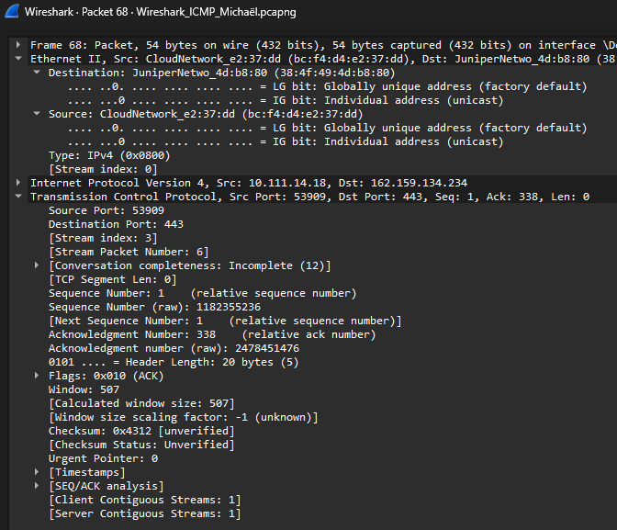
Figure 9 – TCP frame 68: 10.111.14.18:53909 → 162.159.134.234:443, ACK, Seq 1, Ack 338
UDP (Figure 10, frame 11). 162.159.128.233 port 443 to 10.111.14.18 port 55039. UDP length 1208 (8-byte header plus 1200 bytes of payload), and the 1242-byte frame is 14 (Ethernet) + 20 (IPv4) + 8 (UDP) + 1200. Wireshark decodes the payload as QUIC, the transport behind HTTP/3, which runs over UDP port 443.
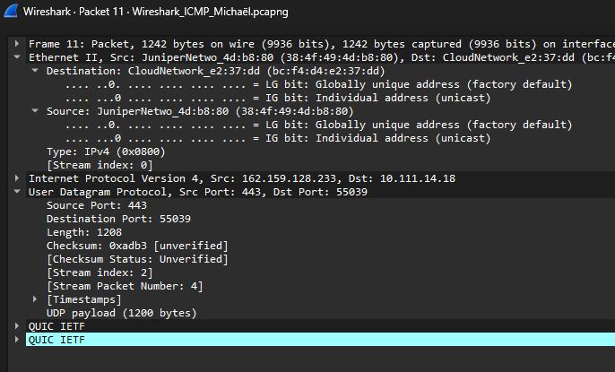
Figure 10 – UDP frame 11: 162.159.128.233:443 → 10.111.14.18:55039, 1200-byte QUIC payload
Summary of observations.
- The trace to www.netfirms.com passed the campus gateway 10.111.0.1 and two more private 10.200.0.x routers before reaching public addresses at hops 4–6 (n-rtr-ext.humber.org, 66.97.22.128 and 66.97.16.3). Figure 4 shows six hops.
- The gateway’s MAC address 38:4f:49:4d:b8:80 is the Ethernet destination of the packet that leaves the subnet (Figure 9) and the Ethernet source of the packets that arrive from outside (Figures 8 and 10).
- DNS (Figure 8) and QUIC (Figure 10) both ride on UDP, while the HTTPS session (Figure 9) rides on TCP.

2.2 Part B – TCP and UDP Protocol Analysis
A new capture was started, http://www.textfiles.com/virus/datut010.txt was opened in the browser, and the capture was stopped and saved as Wireshark_TCPUDP_Michaël.pcapng (Figure 11). Filtering on tcp showed the three-way handshake followed by the HTTP GET (Figure 12).
Figure 11 – Capture saved as Wireshark_TCPUDP_Michaël.pcapng
TCP three-way handshake and HTTP GET (Figure 12). Frame 270 is the SYN from 192.168.0.213 port 50622 to 208.86.224.90 port 80 (Seq=0, Win=65535, MSS=1460, window scale 256, SACK permitted). Frame 271 is the SYN, ACK from the server (Seq=0, Ack=1, MSS=1452). Frame 272 is the client’s ACK (Seq=1, Ack=1). Frame 273 is the HTTP GET /virus/datut010.txt HTTP/1.1 (431 bytes). The time from the SYN to the SYN, ACK was 38.6 ms (11.1847 s to 11.2233 s), which is the round-trip time to the server.
Figure 12 – Filter tcp: SYN (270), SYN-ACK (271), ACK (272) and HTTP GET (273)
Expanded handshake packets (Figures 13 and 14). The SYN-ACK (frame 271) carries flags 0x012 (SYN + ACK), a raw sequence number of 3056207464 and a raw acknowledgement number of 2075258318, which is the client’s initial sequence number plus one. The final ACK (frame 272) has raw sequence 2075258318 and raw acknowledgement 3056207465, which is the server’s initial sequence number plus one. Each SYN uses up one sequence number, which is why each side acknowledges the other’s number plus one. The SYN-ACK has a 32-byte header because of its 12 bytes of options (MSS, NOP, window scale, SACK permitted), while the plain ACK has a 20-byte header. The client’s advertised window of 255 is multiplied by the window scale factor of 256 to give the calculated window of 65280. In both frames one Ethernet address is the gateway’s (04:95:e6:94:f3:f0) and the other is the workstation’s (bc:f4:d4:e2:37:dd); neither belongs to the remote server, whereas the IP addresses are end to end.
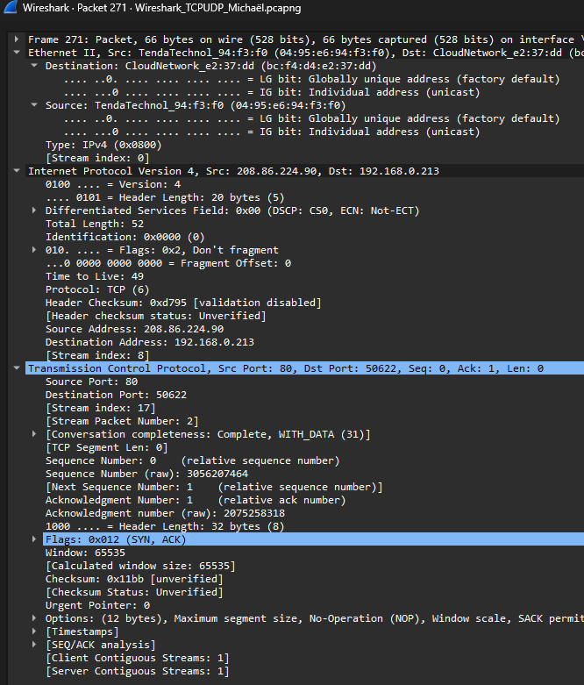  Figure 13 – Frame 271 (SYN, ACK): 208.86.224.90:80 → 192.168.0.213:50622, TTL 49, header 32 bytes | 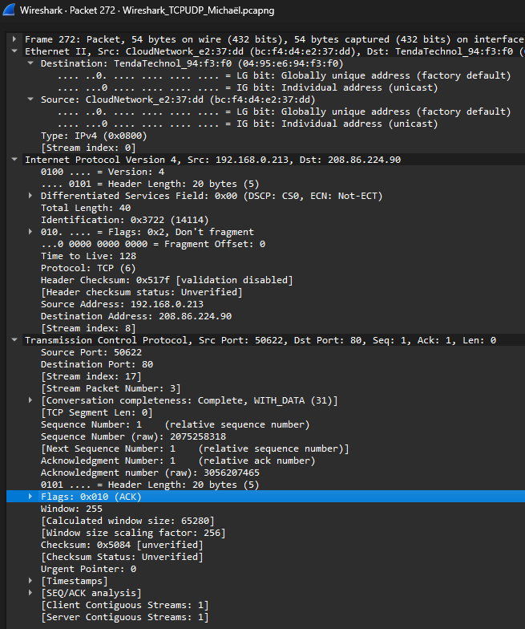  Figure 14 – Frame 272 (ACK): 192.168.0.213:50622 → 208.86.224.90:80, Seq 1, Ack 1, window 255

UDP: NBNS, DNS and DHCP (Figures 15–17). Filtering on udp showed three kinds of short, connectionless exchanges.
NBNS (Figure 15): 10.111.16.166 port 137 to 74.125.48.230 port 137, UDP length 58 (8-byte header plus 50 bytes), NetBIOS name query with transaction ID 0x9465 and one question. NetBIOS over TCP/IP is enabled on the adapter (Figure 3), so Windows sends name queries on UDP 137. The address 74.125.48.230 also appears as a tracert hop in Figure 27, so this query was most likely Windows trying to resolve the name of that router.
DNS query (Figure 16, frame 43): 192.168.0.213 port 51371 to 192.168.0.1 port 53, UDP length 56 (48-byte payload), transaction ID 0xb781, flags 0x0100 (standard query), one question, with the response in frame 46. The source is a random high (ephemeral) port and the destination is the well-known DNS port. The Ethernet destination is the gateway’s MAC address because the router is the DNS server on this network.
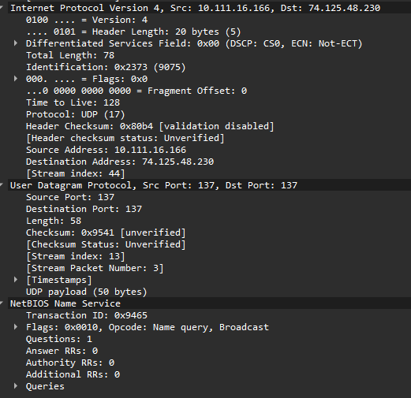  Figure 15 – NBNS: UDP 137 → 137, name query, UDP length 58 | 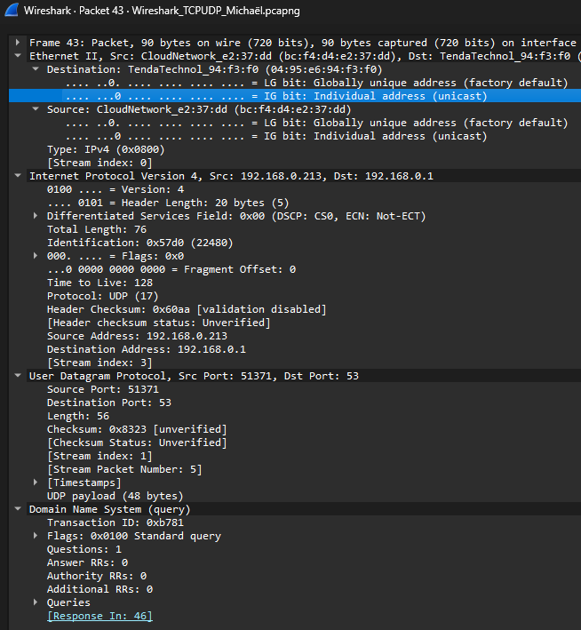  Figure 16 – DNS query, frame 43: 192.168.0.213:51371 → 192.168.0.1:53

DHCP (Figure 17): 10.111.16.166 port 68 to 10.114.128.109 port 67, UDP length 309 (301-byte payload). It is a Boot Request with DHCP message type Request (option 53), the client IP address already filled in, “your IP address” 0.0.0.0, client MAC bc:f4:d4:e2:37:dd and Bootp flags 0x0000 (unicast). Further options include client identifier (61), host name (12), client FQDN (81), vendor class (60) and the parameter request list (55). Because the client already had an address and sent the message directly to the DHCP server shown in Figure 25, this is a lease renewal, not the initial broadcast Discover. It uses the same ports (67 and 68) as the BOOTP step in Lab 01.
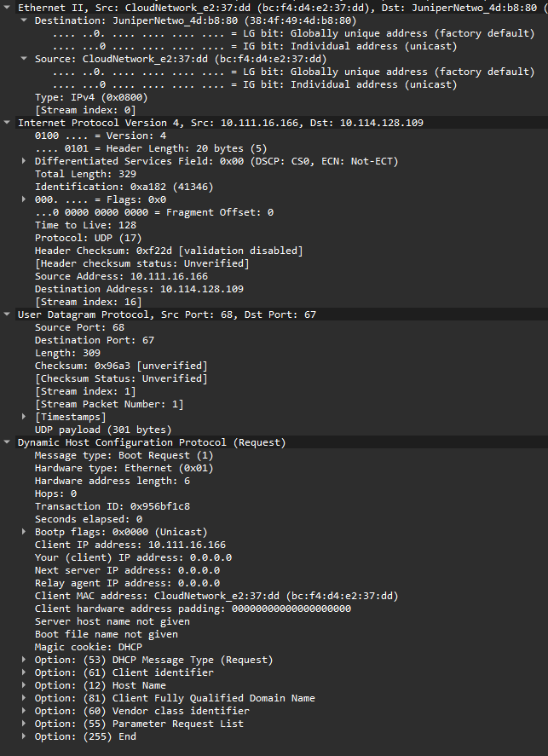
Figure 17 – DHCP Request (renewal): 10.111.16.166:68 → 10.114.128.109:67, unicast
Protocol headers: TCP and UDP (Figures 18 and 19). In the TCP packet (frame 2) 192.168.0.213 port 52103 sends to 162.159.135.234 port 443 with sequence number 1 (raw 66801317), acknowledgement number 240 (raw 356403041), a 20-byte header, flags 0x010 with only the Acknowledgment bit set, window 254 and checksum 0x464d. The client is acknowledging the 239 bytes received so far. The UDP packet (frame 1125) is a broadcast from the gateway: 192.168.0.1 port 9801 to 192.168.0.255 port 9801, Ethernet destination ff:ff:ff:ff:ff:ff, UDP length 107 with 99 bytes of payload, TTL 64 and DSCP CS7. It has no handshake, no sequence numbers and no acknowledgements. Its header has only four fields (source port, destination port, length and checksum), compared with the many fields of the TCP header. Wireshark does not recognise the payload and shows it as raw data.
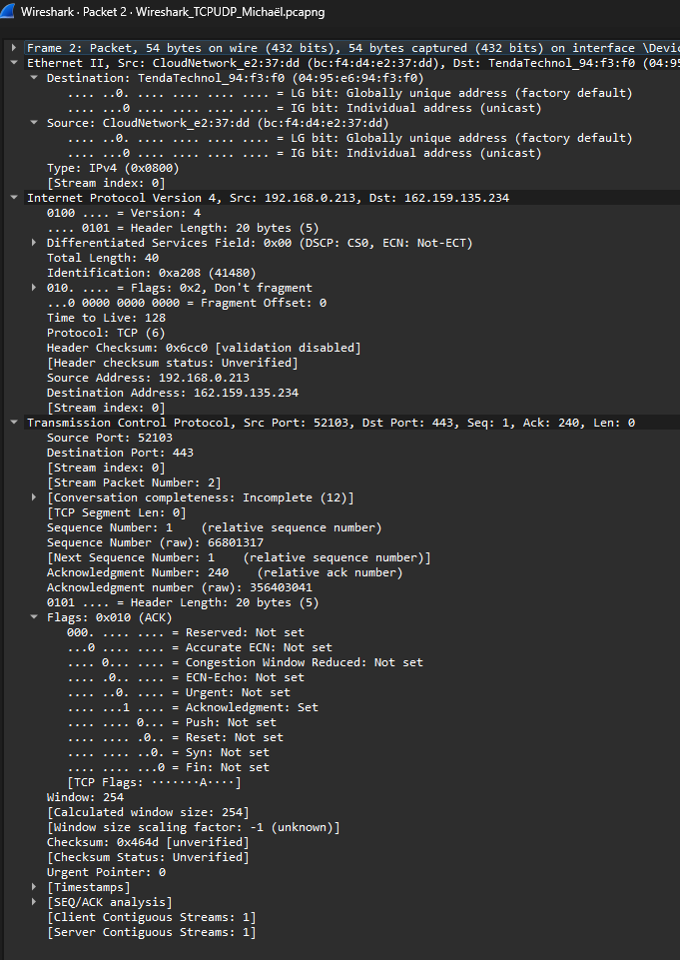  Figure 18 – TCP header, frame 2: ports 52103 → 443, Seq 1, Ack 240, flags 0x010 (ACK) | 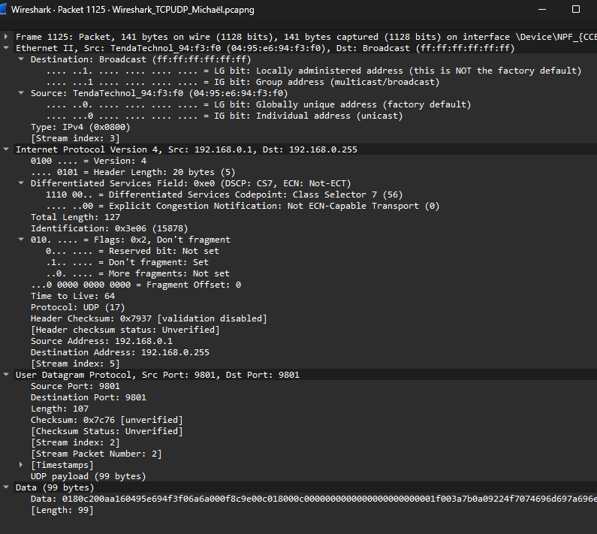  Figure 19 – UDP header, frame 1125: 192.168.0.1:9801 → 192.168.0.255:9801 (broadcast), 99-byte payload

2.3 Part C – Command-Line Tools and Protocol Behaviour
ping (Figures 20–22). ping 8.8.8.8 sent four 32-byte Echo Requests and received four replies (0% loss) in 7–51 ms, average 18 ms, all with TTL 116. With the filter icmp, frame 51 is the request (10.111.16.166 → 8.8.8.8, sequence 43, TTL 128) and frame 52 is the reply from 8.8.8.8 (TTL 116). The expanded packets show Type 8 / Code 0 for the request and Type 0 / Code 0 for the reply, the same identifier (0x0001) and sequence number (43, or 0x002b), and the same 32 bytes of data (the repeating letters a–w that Windows uses). Frame 52 reports a response time of 50.914 ms, matching the 51 ms of the first reply in the command window. The sequence number is shown as 43 (big-endian) and 11008 (little-endian, 0x2b00), which is why the packet list shows seq=43/11008. If 8.8.8.8 started with a TTL of 128, the reply crossed about 12 routers.
Figure 20 – Filter icmp: Echo request (frame 51, TTL 128) and Echo reply (frame 52, TTL 116)
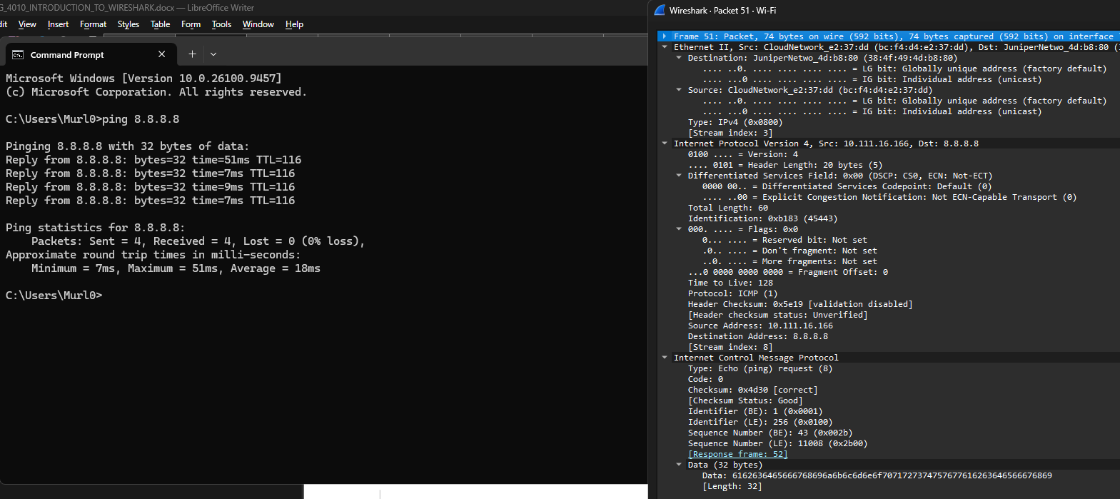
Figure 21 – ping 8.8.8.8 output beside the expanded Echo request (frame 51): Type 8, ID 1, seq 43, TTL 128
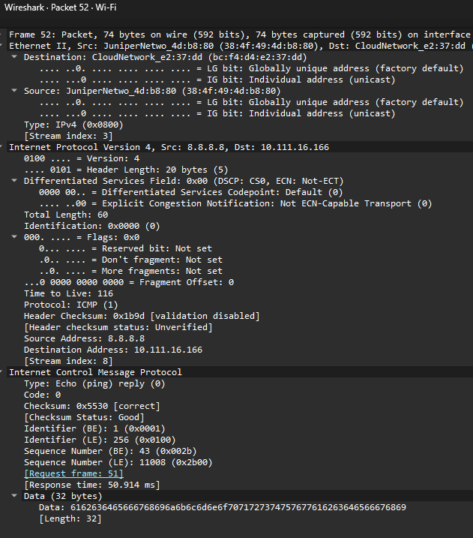
Figure 22 – Expanded Echo reply (frame 52): Type 0, seq 43, TTL 116, response time 50.914 ms
arp -a (Figures 23 and 24). The ARP cache for interface 10.111.16.166 holds one dynamic entry, the gateway 10.111.0.1 at 38-4f-49-4d-b8-80, and several static entries: multicast addresses 224.0.0.22, 224.0.0.251, 224.0.0.252 and 239.255.255.250 mapped to 01-00-5e-xx-xx-xx MAC addresses, and the broadcast address 255.255.255.255 mapped to ff-ff-ff-ff-ff-ff. arp -a itself only reads this table. In Wireshark, the filter arp shows frame 8, a broadcast request: sender bc:f4:d4:e2:37:dd / 10.111.16.166, target MAC 00:00:00:00:00:00, target IP 10.111.0.1. This is the kind of exchange that creates the dynamic gateway entry, and the MAC address it resolves (38:4f:49:4d:b8:80) is the same one seen in the Ethernet headers of Part A.
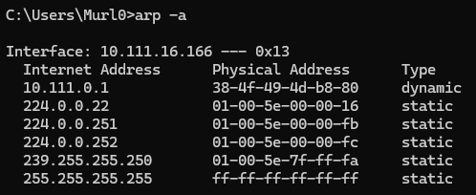
Figure 23 – arp -a: gateway 10.111.0.1 → 38-4f-49-4d-b8-80 (dynamic) and static multicast/broadcast entries
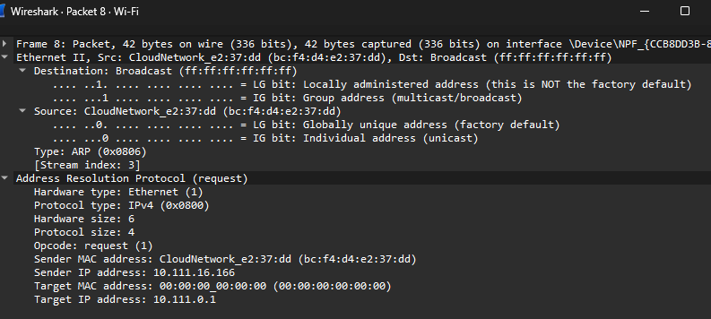
Figure 24 – Filter arp, frame 8: request for 10.111.0.1 from 10.111.16.166
ipconfig /all (Figure 25). The adapter settings were IPv4 address 10.111.16.166, subnet mask 255.255.128.0 (/17, so the subnet is 10.111.0.0 to 10.111.127.255), default gateway 10.111.0.1, MAC address BC-F4-D4-E2-37-DD, DHCP server 10.114.128.109 and DNS servers 10.114.0.252 and 10.114.255.252. The lease was obtained September 17, 2026 at 6:54:55 AM and expires at 9:38:01 AM. Table 3 cross-references these values with the Wireshark headers.
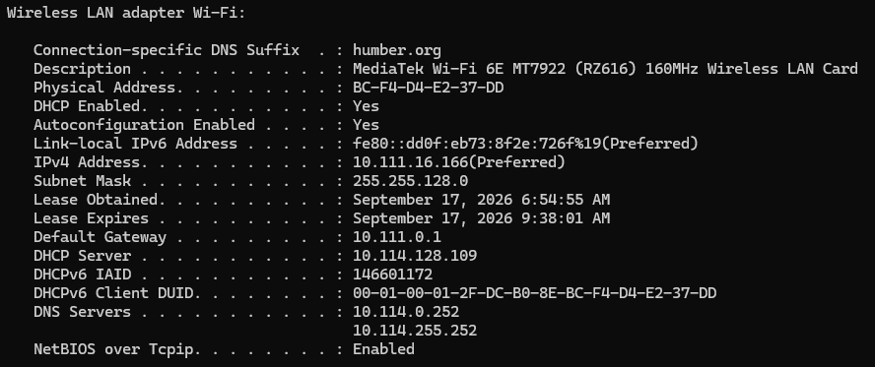
Figure 25 – ipconfig /all (Part C session): IP 10.111.16.166, mask 255.255.128.0, gateway 10.111.0.1
Table 3 – ipconfig values compared with Wireshark headers
Value | ipconfig /all (Figure 25) | Where it appears in Wireshark
Workstation MAC | BC-F4-D4-E2-37-DD | Ethernet source of the Echo request (Figure 21) and the sender MAC of the ARP request (Figure 24)
Workstation IP | 10.111.16.166 | IPv4 source of the Echo request (Figure 21) and the ARP sender IP (Figure 24)
Default gateway | 10.111.0.1 | ARP target IP (Figure 24); its MAC 38-4f-49-4d-b8-80 (Figure 23) is the Ethernet destination of the ping to 8.8.8.8 (Figure 21)
DHCP server | 10.114.128.109 | Destination of the DHCP Request (Figure 17)
Subnet mask | 255.255.128.0 (/17) | 8.8.8.8 is outside 10.111.0.0/17, so the ping was sent to the gateway’s MAC address

netstat -an (Figure 26). The connection captured was TCP 10.111.16.166:60328 to 162.159.135.234:443 in the ESTABLISHED state. The local port 60328 is an ephemeral client port and the remote port 443 is HTTPS. This has the same form as the TCP packets in Figures 9 and 18 (a high client port talking to server port 443), which is how the netstat list is matched to the packet list when the filter tcp or udp is applied.
Figure 26 – netstat -an: 10.111.16.166:60328 → 162.159.135.234:443 ESTABLISHED
tracert www.google.com (Figures 27 and 28). With the filter icmp, frame 355 is a Time-to-live exceeded message from 74.125.48.230, an intermediate router. Frames 375 to 380 are Echo requests to 142.251.150.119 sent with TTL 8 (sequence 68, 69 and 70), each answered by an Echo Reply with TTL 117, so the destination was reached on hop 8 and the three probes at the last hop explain the three times per line. Frame 323 (Figure 28) is a Time Exceeded (Type 11, Code 0) from 66.97.16.3 with TTL 250. It quotes the original datagram: 10.111.16.166 → 142.251.150.119 with TTL 1 and an Echo request with sequence 63. 66.97.16.3 is the router that answered as hop 6 in Part A, so the two traces share the same campus path.
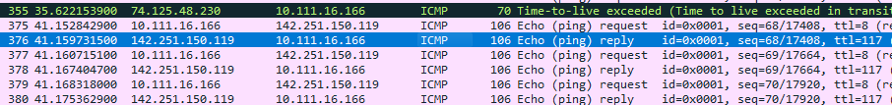
Figure 27 – Filter icmp during tracert www.google.com: Time Exceeded (355) and Echo request/reply pairs at TTL 8
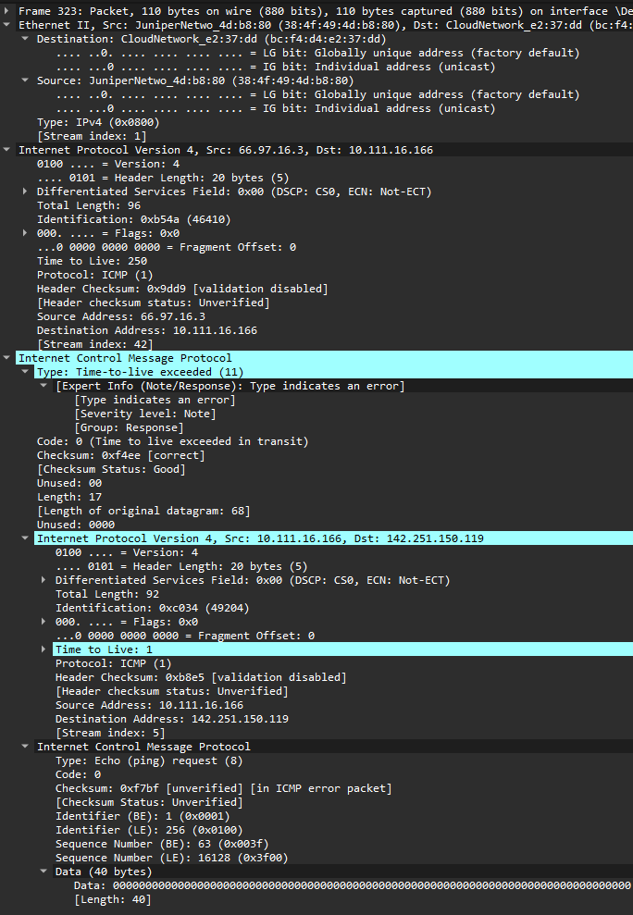
Figure 28 – Time Exceeded, frame 323: 66.97.16.3 → 10.111.16.166, TTL 250, quoting the probe that expired at TTL 1

2.4 Optional Bonus – Header Mapping of One TCP Frame
The ACK in frame 272 (Figure 14) was decomposed field by field. Byte offsets are counted from the first byte of the IPv4 header; the IPv4 header is bytes 0–19 and the TCP header is bytes 20–39. The values match the totals in the screenshot: total length 40 = 20 (IPv4) + 20 (TCP) + 0 (data).
Table 4 – IPv4 and TCP fields of frame 272 (192.168.0.213:50622 → 208.86.224.90:80)
Layer | Field | Byte offset | Length | Value | Hex
IPv4 | Version | 0 | 4 bits | 4 | 0x4
IPv4 | Header length (IHL) | 0 | 4 bits | 5 (20 bytes) | 0x5
IPv4 | DSCP / ECN | 1 | 1 byte | 0 (CS0, Not-ECT) | 0x00
IPv4 | Total length | 2–3 | 2 bytes | 40 | 0x0028
IPv4 | Identification | 4–5 | 2 bytes | 14114 | 0x3722
IPv4 | Flags / fragment offset | 6–7 | 3 + 13 bits | DF set, offset 0 | 0x4000
IPv4 | Time to Live | 8 | 1 byte | 128 | 0x80
IPv4 | Protocol | 9 | 1 byte | 6 (TCP) | 0x06
IPv4 | Header checksum | 10–11 | 2 bytes | 20863 (unverified) | 0x517f
IPv4 | Source address | 12–15 | 4 bytes | 192.168.0.213 | C0 A8 00 D5
IPv4 | Destination address | 16–19 | 4 bytes | 208.86.224.90 | D0 56 E0 5A
TCP | Source port | 20–21 | 2 bytes | 50622 | 0xC5BE
TCP | Destination port | 22–23 | 2 bytes | 80 | 0x0050
TCP | Sequence number (raw) | 24–27 | 4 bytes | 2075258318 | 0x7BB1EDCE
TCP | Acknowledgement number (raw) | 28–31 | 4 bytes | 3056207465 | 0xB62A0669
TCP | Data offset + flags | 32–33 | 4 + 12 bits | offset 5 (20 bytes), flags 0x010 (ACK) | 0x5010
TCP | Window | 34–35 | 2 bytes | 255 (× 256 = 65280) | 0x00FF
TCP | Checksum | 36–37 | 2 bytes | 20612 (unverified) | 0x5084
TCP | Urgent pointer | 38–39 | 2 bytes | 0 | 0x0000

3. Results and Reflection

3.1 Link to theory
Encapsulation. Each packet in the figures is a stack of headers that follows the layered model. Ethernet II (layer 2) carries the MAC addresses and a type field: 0x0800 for IPv4 and 0x0806 for ARP. IPv4 (layer 3) carries the source and destination IP addresses, the TTL and a protocol field: 1 for ICMP (Figure 28), 6 for TCP (Figure 14) and 17 for UDP (Figures 16 and 17). The transport header adds ports, and the application data (DNS, DHCP, HTTP, QUIC) follows.
IP and MAC addressing. The IP addresses stay the same from end to end, but the MAC addresses only cover the local link. Whenever the destination is outside the subnet, the workstation puts the gateway’s MAC address in the Ethernet header: 38:4f:49:4d:b8:80 in Figures 9 and 21, and 04:95:e6:94:f3:f0 in Part B. The subnet mask decides what is local: with 255.255.128.0, 10.111.14.18 and 10.111.16.166 are on the same /17 network as the gateway 10.111.0.1, but 8.8.8.8 is not. ARP finds the gateway’s MAC address from its IP address (Figure 24) and stores it in the cache shown by arp -a (Figure 23).
TTL and ICMP. TTL prevents packets from looping forever and makes traceroute possible (Section 2.1). The TTL values also reveal the sender’s operating system default: the workstation’s own packets left with TTL 128 (Figures 14 and 21), the Time Exceeded message in Figure 28 arrived with TTL 250, which fits a router that starts at 255 and whose reply crossed five routers on the way back, and the ping reply from 8.8.8.8 arrived with TTL 116. A reply’s TTL is set by the replying device, so it says nothing about the forward hop count; the hop count comes from the TTL of the probes (8 for Google, Figure 27).
TCP versus UDP. TCP is connection-oriented: the SYN, SYN-ACK and ACK handshake (Figures 12–14) synchronises the initial sequence numbers, and the acknowledgement number is always the next byte expected (Figures 9 and 18). This gives reliable, ordered delivery, which HTTP and HTTPS need. UDP has no handshake and an 8-byte header (Figure 19), which suits short request and response exchanges such as DNS, DHCP and NBNS and the QUIC transport used by HTTP/3. Well-known ports identify the service (53, 67, 68, 80, 137 and 443), while clients use ephemeral ports (for example 50622, 51371 and 60328).
Industrial relevance. The same analysis applies to industrial traffic. EtherNet/IP uses TCP port 44818 for explicit messaging and UDP port 2222 for I/O data, Modbus/TCP uses TCP port 502 and S7comm uses TCP port 102, and Wireshark can decode all of them. Address conflicts, ARP problems and BOOTP/DHCP behaviour, which were configured in Lab 01, can be diagnosed with the same filters and headers.

3.2 Comparison of protocols
Protocol | Layer / transport | Purpose | Evidence in this lab
ICMP | Network layer (IP protocol 1) | Error reporting and reachability: Echo (Types 8 and 0) and Time Exceeded (Type 11) | Figures 6, 20–22, 27 and 28
ARP | Link layer (EtherType 0x0806), no IP header | Resolves an IPv4 address to a MAC address on the local subnet | Figures 7, 23 and 24
DNS | UDP port 53 | Resolves names to IP addresses | Figures 8 and 16
TCP | Transport (IP protocol 6) | Reliable, connection-oriented delivery for HTTP (80) and HTTPS (443) | Figures 9, 12–14, 18 and 26
UDP | Transport (IP protocol 17) | Connectionless, low-overhead delivery (QUIC, NBNS, DNS, DHCP) | Figures 10, 15 and 19
DHCP | UDP ports 67 and 68 | Leases an IP address and network settings to a client | Figures 17 and 25
NBNS | UDP port 137 | NetBIOS name resolution | Figure 15

HTTP appeared only as the GET request in Figure 12. LLDP was not seen: it is a link-local protocol sent between directly connected devices and is not forwarded, so a capture on a wireless interface would not normally show it.

3.3 Errors and limitations
- Different networks and sessions. The captures were taken on more than one network (Table 2), so the workstation address changes between figures (10.111.14.18, 192.168.0.213 and 10.111.16.166). Each figure is correct for its own session, but it means Part B’s TCP packets cannot be matched directly with Part C’s netstat entry.
- Traceroute output only partly documented. Figure 4 shows the first six hops of the trace to www.netfirms.com, so the total hop count and the final Echo Reply from 104.18.38.156 are not shown. The hop count for www.google.com (8) was taken from the TTL of the probes in Wireshark instead (Figure 27).
- Checksums show as “unverified”. Wireshark does not validate IP, TCP or UDP checksums by default, and outgoing packets are captured before the network adapter fills in the checksum (checksum offload). The unverified status in Figures 9, 14 and 19 is therefore expected and is not a transmission error. ICMP checksums were reported as correct (Figures 6 and 28).
- ARP results are incomplete. Figures 7 and 24 show requests only, without the matching replies, and the request in Figure 7 is for an unusual link-local target (169.254.169.254) whose source was not investigated. The UDP broadcast on port 9801 (Figure 19) was also not identified.
- Assumed initial TTL values. Estimating the number of routers on a return path from a reply’s TTL (for example 128 − 116 for 8.8.8.8) assumes the sender’s default starting TTL (64, 128 or 255), which cannot be confirmed from the capture.
- Encrypted and limited visibility. HTTPS and QUIC payloads are encrypted, so only headers could be analysed. A capture on a Wi-Fi interface also shows only traffic to and from the workstation plus broadcast and multicast frames, so traffic between other hosts was not visible.

3.4 Possible improvements
- Capture all three parts in one session on one network and record ipconfig /all at the start of each part, so that every figure uses the same addresses.
- Save the complete tracert output (every hop and the final reply) and use a filter such as icmp.type == 11 or icmp.type == 0 to pair each hop with its Time Exceeded message.
- Use filters such as tcp.flags.syn == 1, tcp.port == 443 and Statistics → Conversations to isolate a single connection, and run netstat -ano so that each port in the list can be matched to a process.
- Include both the ARP request and the reply for every ARP example, and expand the DNS Queries section so that the queried name is visible.
- Repeat the Lab 01 BOOTP step with a capture running on the wired interface. The PLC’s BOOTP request (UDP port 68 to 67) and any reply would show whether the address was actually assigned, which was left unconfirmed in Lab 01. A mirrored switch port would also allow LLDP and EtherNet/IP traffic to be captured.
- Add coloured boxes around the fields discussed in each screenshot so the annotated values are easy to find.

Appendix – Application Photos
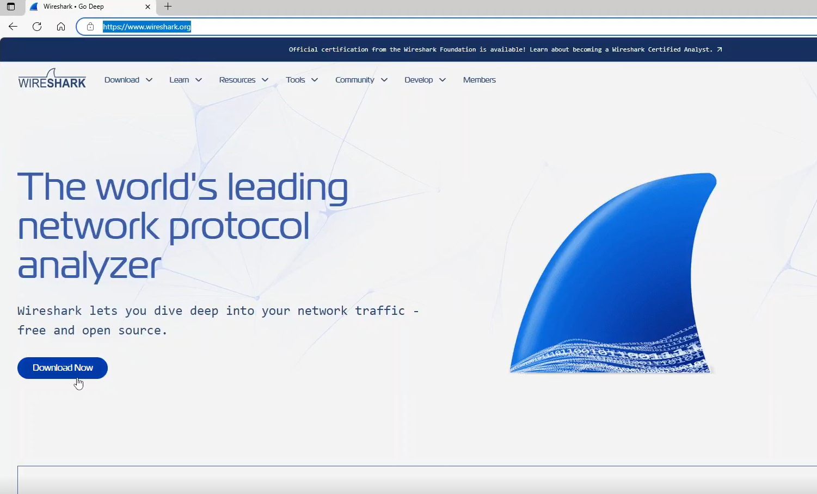
Figure 29 – Wireshark website (https://www.wireshark.org), the source of the installer

